Docker Assignment-4

**Question**: From the git repo having two branches 2024Q1 and 2024Q2 with file index.html deploy that on two slaves of Jenkins using SSH connection on port 80 for both slaves use Docker volumes for the purpose.

* Launce a ec2 instance
* Install java 11
* Install Tomcat
* Download Jenkins war file in webapps folder of Tomcat and start the Tomcat.
* Create a Github repo with 2 branches as shown is SS below and insert a index.html file in it.

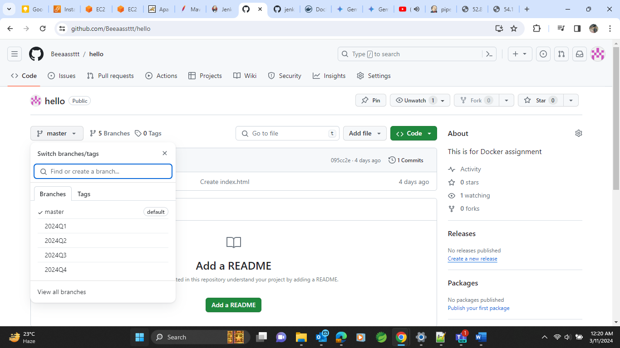

* Do connection of slaves with Master with SSH connection
* Create and home root path for slaves named as “slave-1” and “slave-2” for both slaves of slave1 and slave2 accordingly.
* Do SSH connection with configs like

* Follow the above process for both slaves according to their configs
* Both slave will now be having connection with Master now as shown below

* After all the configurations as per shown in previous docs of Jenkins assignment we will be able to see Jenkins UI like this.

* Create a job here named as pipeline-volume-4 with pipeline option selected and do some configurations shown in ss below

Save and apply to run the build.

* We will achieve our required output showing like 2024Q1 branch index file on slave 1 and 2024Q2 branch index file on slave-2 on port 80 for both
* **This is for slave 1**

* **This is for slave 2**

